Celebrate the Holiday
Season in Pinetops

Christmas Tree Lighting Ceremony
Thursday, December 1, 2022
7:00 PM Town Gazebo
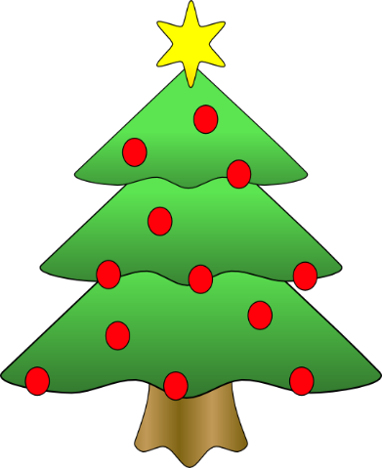

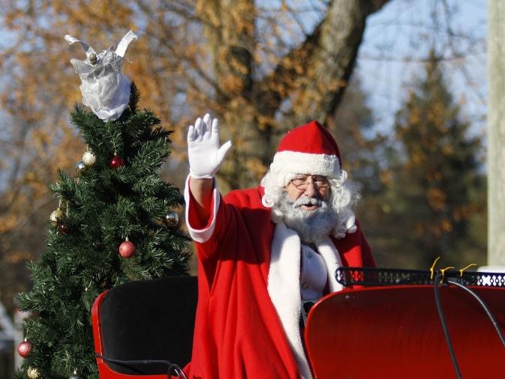
46th Annual Pinetops
Christmas Parade
Saturday December 3, 2022
10:00 AM

50/50 Raffle
Saturday December 3, 2022
10:00 AM

